GWS21A – Atigun Pass – AAB01 Freewave Radio Testing
Last Update: 20211001, M. Lilly

Freewave Diagnostics 2.16 screen captures
Screen 0
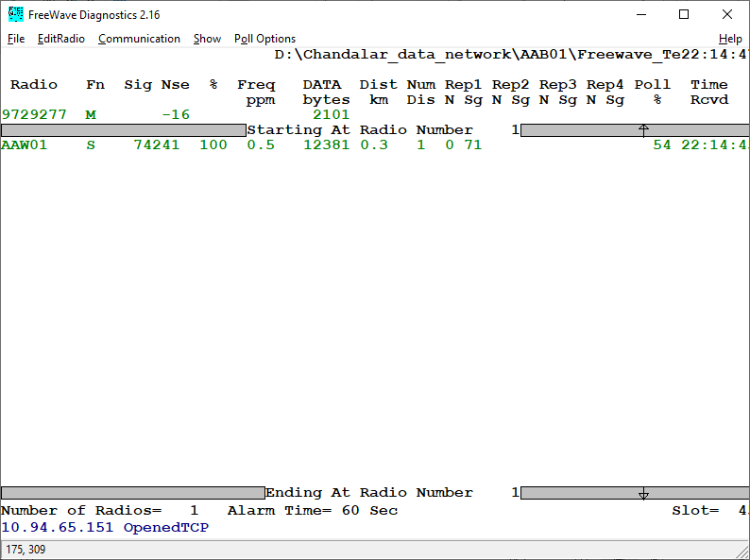
Screen 1
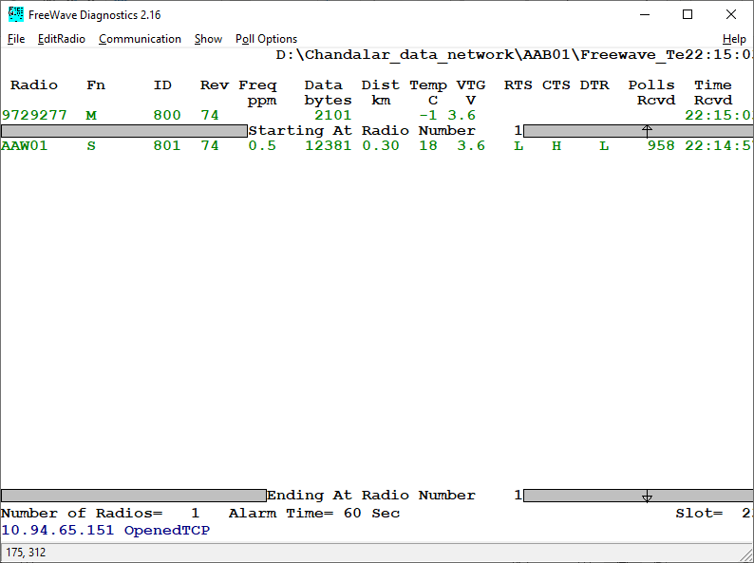
Screen 2
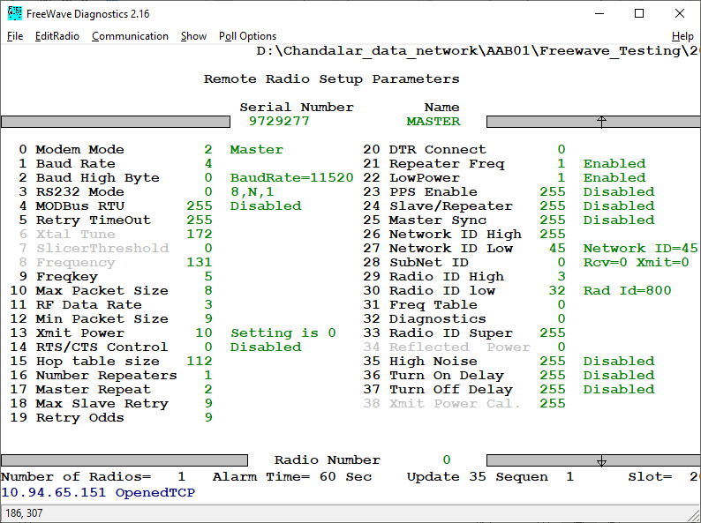
Screen 2 – AAW01
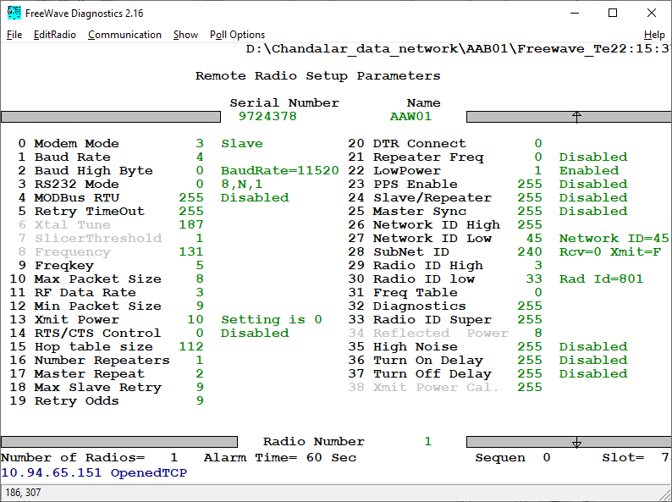
Screen 3 – AAB01
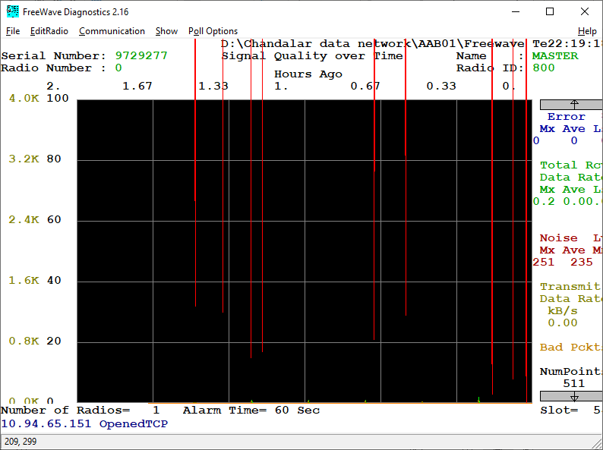
Screen 3 – AAW01

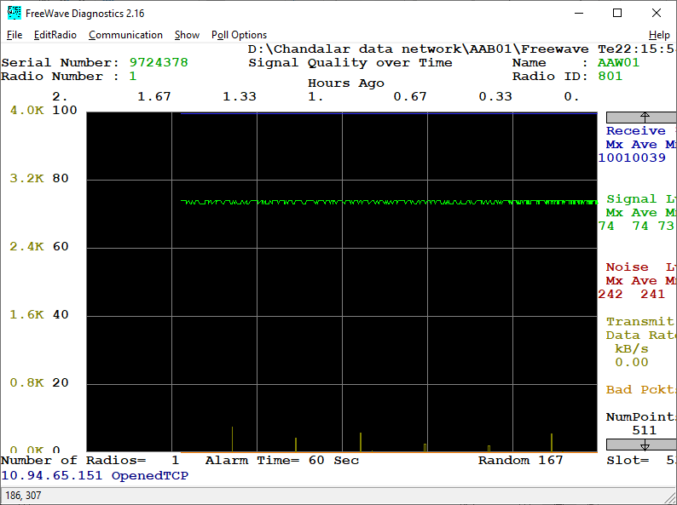
Screen 4 – AAB01
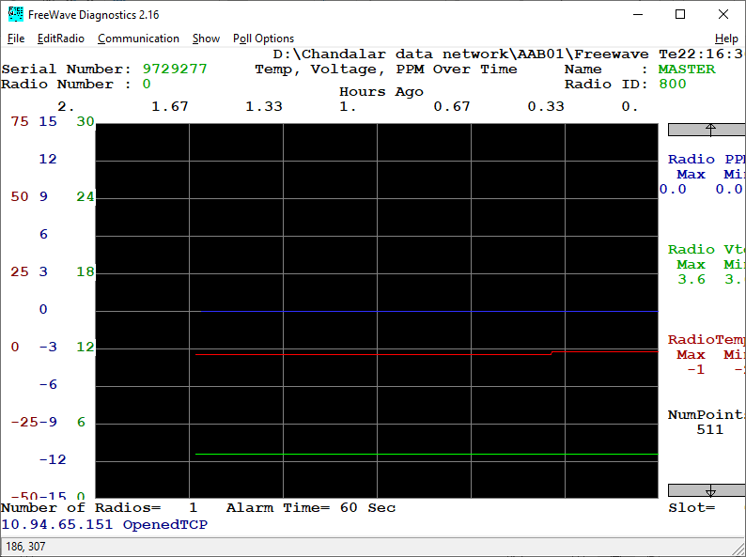
Screen 4 – AAW01
